Hadoop is a framework which supports "write once read many" idea. Since haoop is not real-time, storing transactional data in HADOOP is still a challenge. For transactional data RDBMS is still preferred.
Also Hadoop does not care of consistency so data may be redundant or incorretly updated for transactions.
ex, u make a deposit of 10000 to ur bank and ur wife withdraws 10000 in a matter of secs. Hadoop will not be able to handle these consistently as name node will take time to replicate the deposit in data node while RDBMS can handle the transactions in a matter of seconds.
Data Ecosystem in an enterprise will look like,
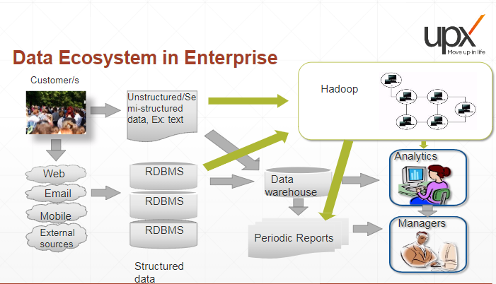
NOTE: both ware house and Hadoop can be used for analytics but hadoop allows enhanced/predictive analytics while data warehouse provides limited analytics.
Hadoop Advantages | Hadoop disadvantages
can store large amount of data and | Hadoop is inefficient while processing small files.
provides programming framework.| Hadoop cannot handle random access data
Hadoop can store and process | retrieval (RADR) i.e. select * kind of queries.
unstructured data sequentially*. | Hadoop cannot handle DMLs.
Hadoop can handle large batch | Hadoop does not handle ACID properties as efficiently
process. |as RDBMS do.
hadoop scales up cost linearly as |
space issues can be handled by |
adding horizontal scaling of |
commodity hardware. |

*Hadoop stores data sequentially but process them parallel.
NOTE: Hadoop can access both linux and hadoop file system name space.
HDFS:
HDFS works on the top of underlying file system (ex, linux file system)
HDFS is aware of the topology of the data centre i.e. how the data nodes re placed within a data centre and among different data centre.
There are 2 versions of Hadoop: version 1.0 (which is obsolete now, support has been withdrawn) and version 2.0 (which is running and has considerable changes).
hadoop 1.0:
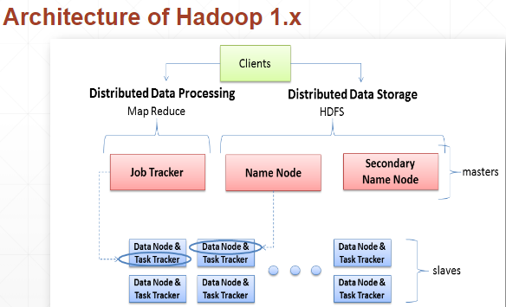
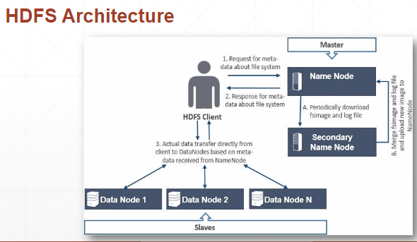

HDFS client: is an interface used to communicate with HDFS.
Basic filesystem client "hdfs dfs" is used to connect to HDFS and perform file related tasks.
Clients can be invoked by CLI (command line interface) commands from a node where hadoop is installed.
NOTE: HDFS client can directly transfer data to data nodes based on meta-data received from NN.
SNN (secondary name node): IT IS NOT A BACKUP NODE (or STAND-BY NODE). It maintains metadata consistency.
NOTE: backup node is a concept that came with Hadoop 2.0.It was not present in Hadoop 1.0.
replication factor : number of times a block is replicated across data nodes. hadoop RF is 3 and each block is 128MB in cloudera installation (by default).

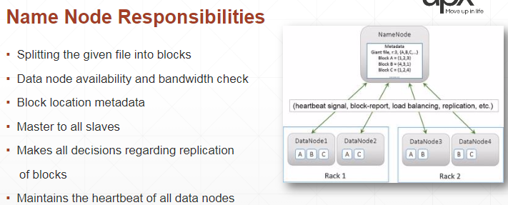
File snapshot (FS) image has info like snapshot of the data ex, usage, files stored, block size, files shared).
FS is updated by SNN which maintains metadata-Editlog. When NN is witched on, SNN provides the editLog which NN then uses to integrate/ update the FS Image.
NN does not do this as it will add to overhead to NN so SNN takes it up.
NN also maintains checkpoints as to when it will contact SNN to update the FS Image to implement consistency.

FS Image to keep the file system consistent

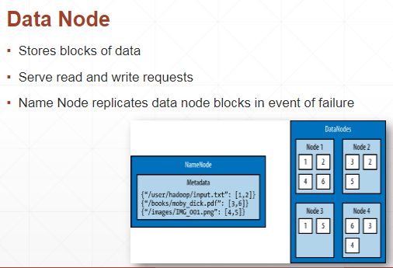
Where the data is processed. MapReduce program runs on the DN.

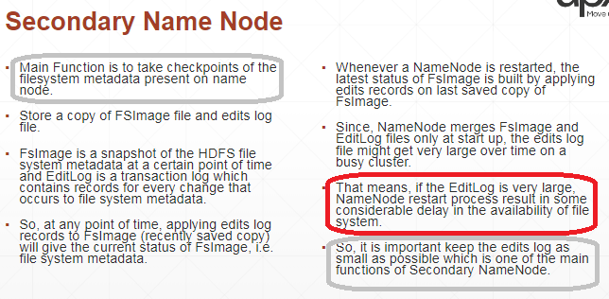
id the edit log is large it means that the data is being written frequently. So the name node restarts the file cluster.

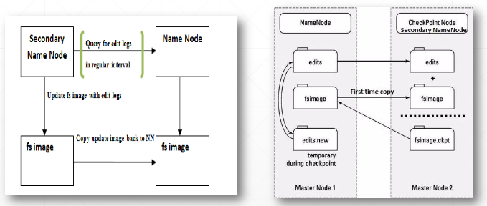
SNN also has a copy of FS Image file to maintain consistency.
SNN edit file is rejected by NN if the file system has no changes and if the SNN is down for sometime (then NN has no reason to trust it)

if Master Node 2 is passive it works as Backup NN.
If Master node 2 is active, it also works as SNN.

Job Tracker: is only available in HADOOP 1.x and no longer used in HADOOP 2.x.
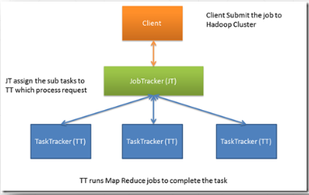
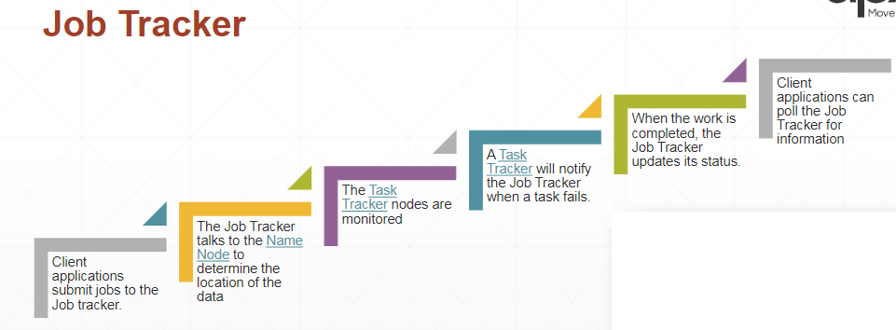
TT calculates intermediate results and send to JT.
I give a job to job tracker. JT talks to NN to check if data is available and resources to perform this job..
NN takes i/p from JT and sends it to Task Tracker (in DN). Task will be to count transaction in florida or CAL.
ex, walmart (client) wants to search the customer making the most no. of transactions in North America. NOTE: each hour Walmart process 1 M transactions

NOTE: Client only interacts with JT. JT gets the work done and actual work is done by TT.


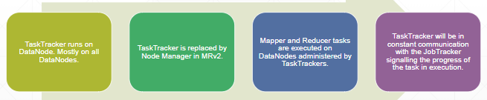
in DN, actual execution takes place.
NM controls node. TC that node is healthy and works.

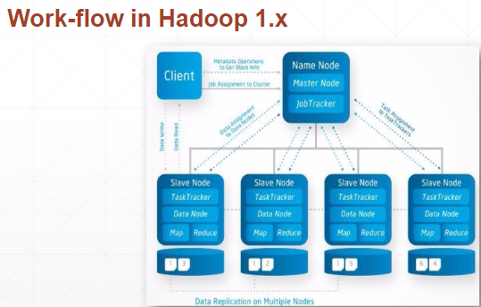

RACKS:
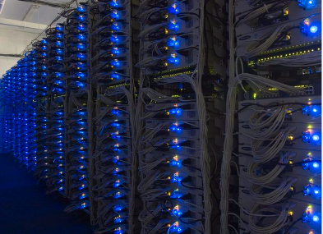
each column is a RACK.
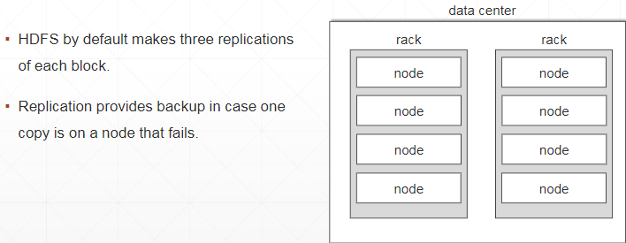
NOTE: HDFS is aware of the data center's topology.
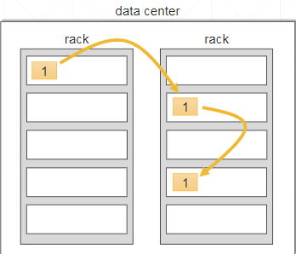
This is default Hadoop installation. Can be changed. This is done as communication between nodes in a rack is easier than across racks.
Data will survive even if the entire rack fails.

RACK Awareness:
1) Allows efficient data placement (data writes, commissioning/de-commissioning of nodes). This facilitates data placement. If HDFS is not rack aware, it will place data replicas in random DNs.
2) each node is assigned a rack (specified by rack-id).

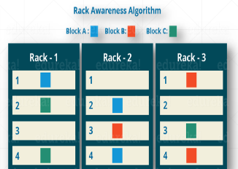
File read in HDFS:
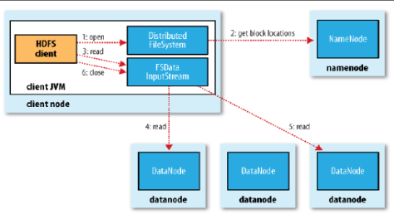
background process which reads data in the form of blocks.
Client sees the data in files itself.

File write in HDFS (files are usually written less than read. "Write once, read many" ideals):
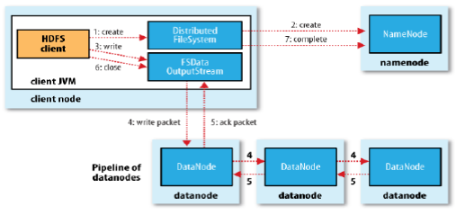
i.e. writes blocks.

Hadoop 2.x:

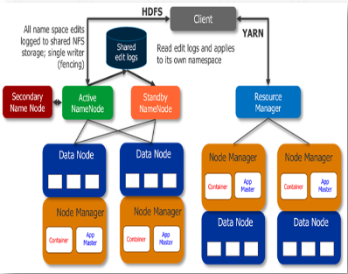
Yet Another resource negotiator (YARN).
is responsible for providing computational resource.

Comprises of 2 components:
1) Resource manager
2) Node manager

YARN:
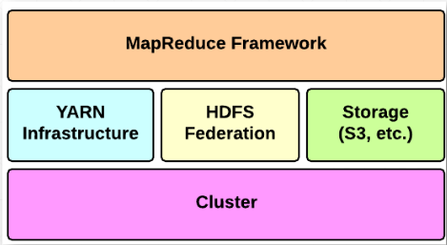
are hardware computational resources.

YARN Components:
Application master is a process that executes task on data node.
Liveness monitor looks for heartbeat
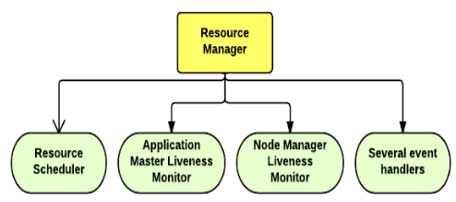

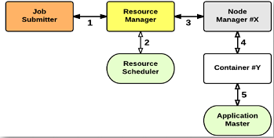
deals only with calculation. Ensures calculation is happening.
NM creates container (i.e. environment where execution happens)
which DN will execute the task

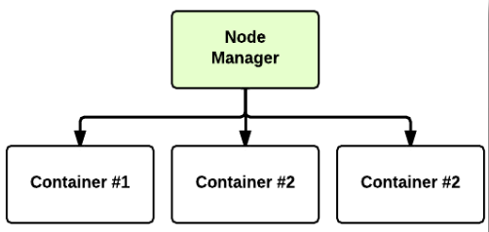

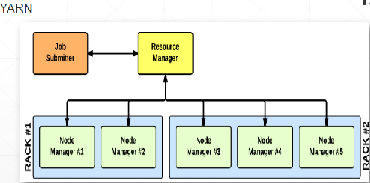

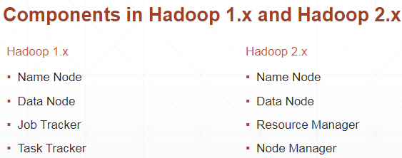

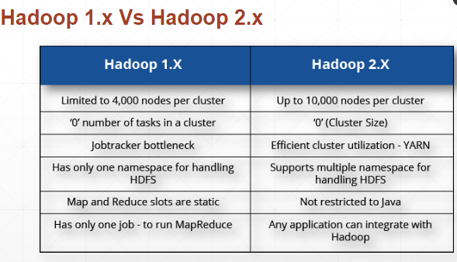
YARN has more capabilities. JD only tracks jobs. YARN has more resources reporting to it. JD does all by itself and so slow.

